**Pillar Seminary Setup Environment**

**1.** Config project.  
 + install nodejs with command

- sudo apt-get update

- sudo apt-get install nodejs

2. Install **npm**

- with command **sudo spt-get install npm** make sure in the system ubuntu have **nodejs** and **npm**

3. cd to project PillarSeminary

run command sudo **npm install** to get all module of nodejs for project.

4. with mongodb need to a tools view data structure.

- install robomongo with package download from website <https://robomongo.org/> .

- open robomongo create database

'server': 'localhost',

'port': '27017',

'db_name': 'pillarseminary'

connect to server with port and server above.

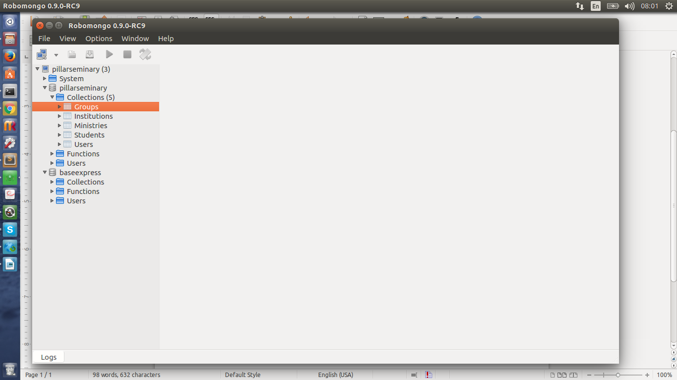

Insert data to collection with example in **mongo-data.js**

5. Run project

after pass 4 step back to project with command line

run command **node index.js** to run server node js with port 3000 (localhost:3000)

authenticate with google account

**smsadmin@pillarseminary.org/S&ubey7C**